https://www.easyuefi.com/wintousb/resource/create-windows-to-go-with-windows-10-professional-edition.html:

How to create Windows To Go using Windows 10 Professional Edition?
2017-7-9, Posted by Admin to Windows To Go Creator
User Guide: How to use Windows 10 Professional Edition to create Windows To Go USB drive with WinToUSB?
Contents
1. Connect the USB drive to the computer. 1
2. Prepare the partitions if you are using an external hard drive to create Windows To Go. 1
3. Download, install and run WinToUSB. 2
4. Click the 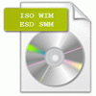 button, then click the button and select Windows 10 professional installation ISO file from the open dialog box. 2
5. WinToUSB will list all installable operating systems in the Windows 10 professional installation ISO. 2
6. Select the destination disk in the drop-down list. 2
7. Select the boot partition and system partition from the partition list, the selected partitions will be marked as red. 3
8. After clicking "Next", WinToUSB begins installing Windows 10 professional to the USB drive. 4
9. It takes some time to install. After installation restart the computer and change BIOS to boot from your USB drive 5
10. Windows 10 professional normal installation starts up and you have to complete all the installation steps. 5

Connect the USB drive to the computer.

Prepare the partitions if you are using an external hard drive to create Windows To Go.
You do not need to perform this step if you are using a USB flash drive to create Windows To Go, WinToUSB will help you to format the USB flash drive in setp 6.
- Booting both BIOS-based and UEFI-based computers (Recommended): Please convert the USB drive to MBR partition scheme and create the system and boot partitions. The system partition must be FAT32 format and the boot partition must be NTFS format.
- Booting BIOS-based computers: Please convert the USB drive to MBR partition scheme and create the system and boot partitions. The system partition can be FAT32 or NTFS format and the boot partition must be NTFS format. The system partition and boot partition can be the same partition.
- Booting UEFI-based computers: Please convert the USB drive to GPT partition scheme and create the EFI system partition (ESP) and boot partition. The EFI system partition must be FAT32 format and the boot partition must be NTFS format.
Tips:
- Both the system partition and boot partition must be primary partition, and we recommend using built-in Disk Management tool in Windows to partition and format the disk.
- The destination boot partition must be a NTFS primary partition and at least 14 GB.
- The destination system partition must be a NTFS/FAT32 primary partition. If the destination system partition is a FAT32 partition, then it must be greater than or equal to 40 MB and less than or equal to 32 GB. (The recommended size is 100 MB.)

Download, install and run WinToUSB.

Click the button, then click the button and select Windows 10 professional installation ISO file from the open dialog box.

WinToUSB will list all installable operating systems in the Windows 10 professional installation ISO.
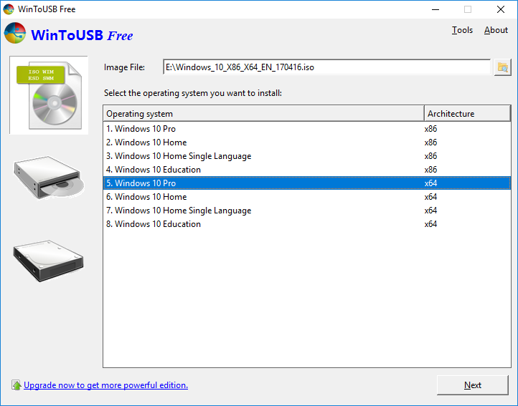
Please select the professional edition, then click "Next".

Select the destination disk in the drop-down list.
If your USB drive is not correctly recognized by WinToUSB, you need to click the button for the program to recognize the USB drive. If you are using a USB flash drive to create Windows To Go, a pop-up will appear asking you if you want to format it to continue. Select the partition scheme you want to use and click "Yes" to format it.

Select the boot partition and system partition from the partition list, the selected partitions will be marked as red.
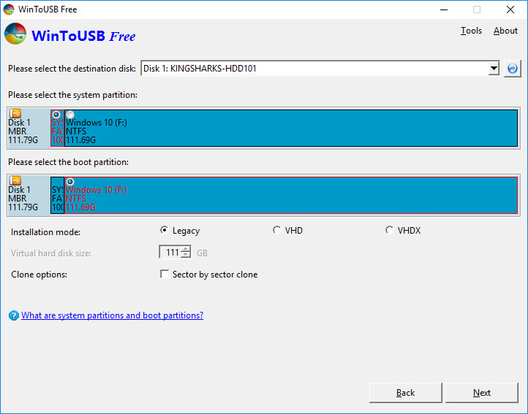

After clicking "Next", WinToUSB begins installing Windows 10 professional to the USB drive.
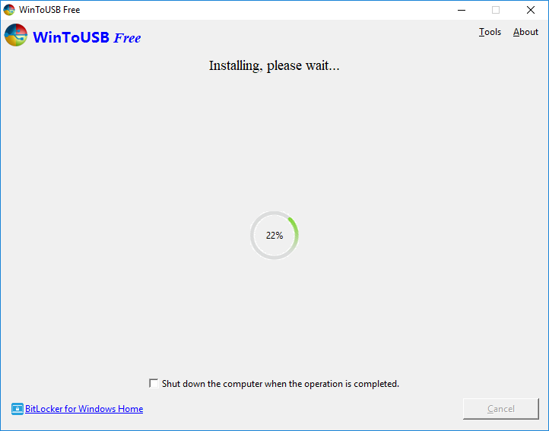

It takes some time to install. After installation restart the computer and change BIOS to boot from your USB drive
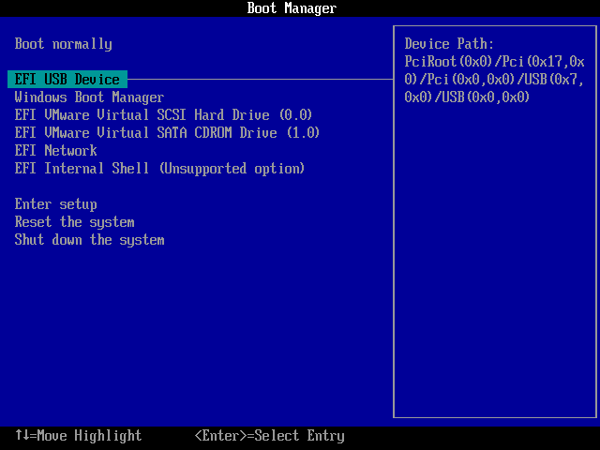

Windows 10 professional normal installation starts up and you have to complete all the installation steps.
After that, you can install programs, copy files, etc.

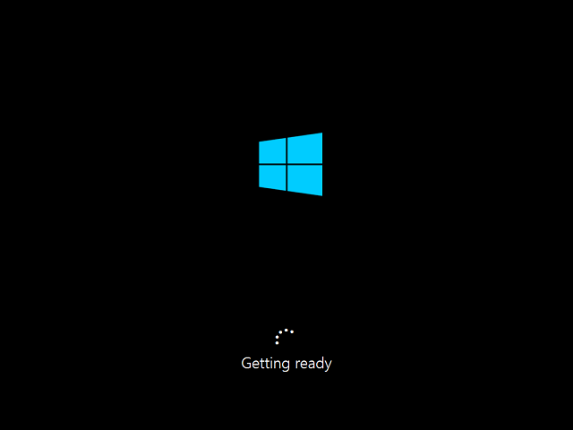
Follow these simple steps, you can easily create a Windows To Go USB drive from Windows 10 Professional installation ISO by using WinToUSB. Now you can carry this Windows 10 Professional To Go USB drive to anywhere and use it on any computer.

